Project Design Phase-II
Data Flow Diagram & User Stories

Date | 30 September 2026
Team ID | SWTID-2026-2843
Project Name | AI-Weatherwise API
Maximum Marks | 4 Marks

Data Flow Diagrams:
• User → Weatherwise API: User enters a location or requests weather information.
• Weatherwise API → Weather Data Source: API collects real-time weather data such as temperature, humidity, wind speed, and rainfall.

Example: (Simplified)
Example: DFD Level 0 (Industry Standard)
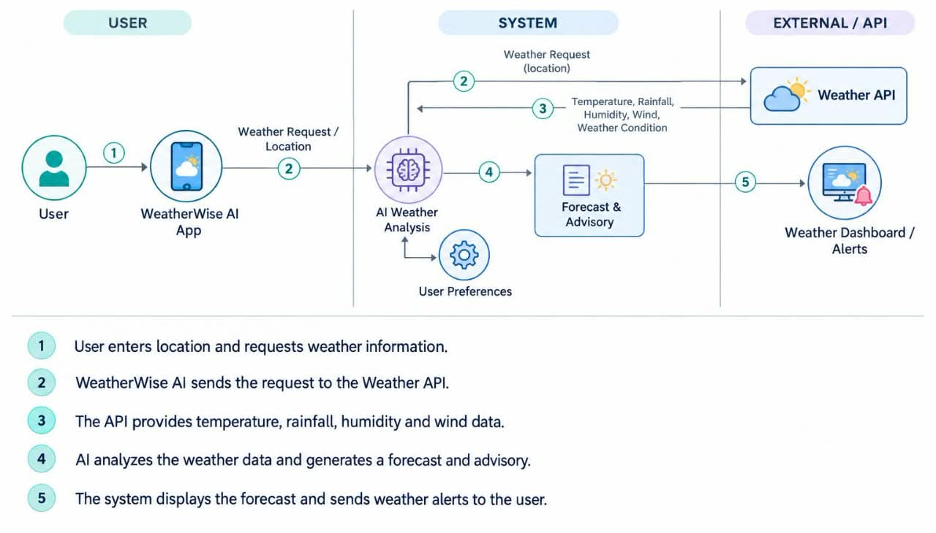
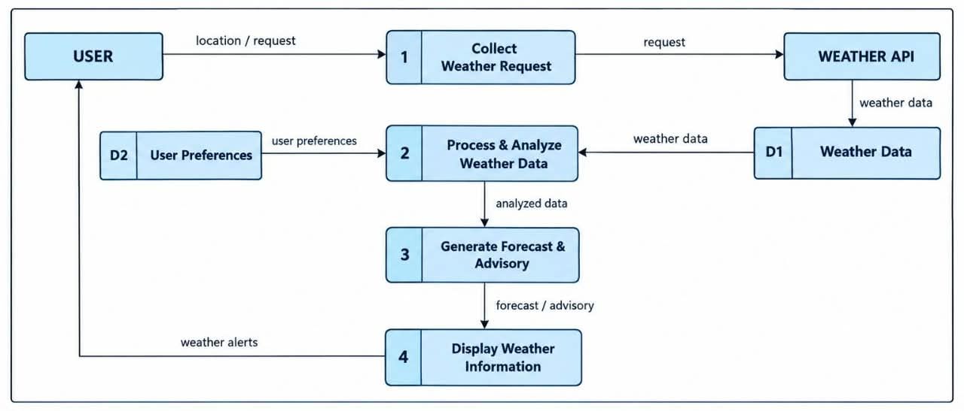

User Stories
Use the below template to list all the user stories for the product.
User Type | Functional Requirement (Epic) | User Story Number | User Story / Task | Acceptance criteria | Priority | Release
Customer (Mobile user) | Registration | USN-1 | As a user, I can register for the application by entering my email, password, and confirming my password. | I can access my account / dashboard | High | Sprint-1
 |  | USN-2 | As a user, I will receive confirmation email once I have registered for the application | I can receive confirmation email & click confirm | High | Sprint-1
 |  | USN-3 | As a user, I can register for the application through Facebook | I can register & access the dashboard with Facebook Login | Low | Sprint-2
 |  | USN-4 | As a user, I can register for the application through Gmail | I can register and access the Weather-wise dashboard with Google Login. | Medium | Sprint-1
 | Login | USN-5 | As a user, I can log into the application by entering email & password | I can access my Weather-wise dashboard. | High | Sprint-1
 | Dashboard | USN-6 | As a user, I can view current weather information on the dashboard. | I can view temperature, humidity, wind speed and weather condition | High
  Sprint-3
Customer (Web user) | Weather Search | USN-7 | As a web user, I can search for weather information by entering a city or location. | I can view weather information for the selected location. | High | Sprint-2
Customer Care Executive | Customer Support | USN-8 | As a customer care executive, I can view and respond to user weather-related queries. | I can view and respond to customer queries. | Medium | Sprint-2
Administrator | User Management | USN-9 | As an administrator, I can manage registered Weather-wise users. | I can view, update and deactivate user accounts. | High
  Sprint-3
 | Weather Data Management | USN-10 | As an administrator, I can monitor weather data received from the API. | I can view and monitor the weather data correctly. | High
  Sprint-3
 | Weather Forecast | USN-11 | As a user, I can view the weather forecast for upcoming days. | I can view the forecast for the selected location | High | Sprint-2
 | AI Weather Prediction | USN-12 | As a user, I can receive AI-based weather predictions and insights | AI weather predictions are displayed clearly. | High | Sprint-2

